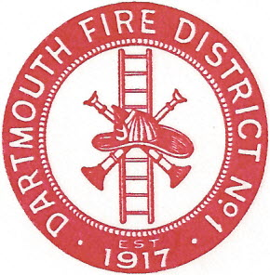
Dartmouth Fire District No.1
10 Bridge Street • Dartmouth, MA 02748
Telephone (508) 996-1596 • Fax (508) 984-4521

Agenda for March 23, 2017 @ 7:30 PM

- Meeting minutes to approve; October 12, 2016, February 8, 2017, April 6, 2016
- Preparation for May annual warrant
- Department by-laws
- Adjourn

